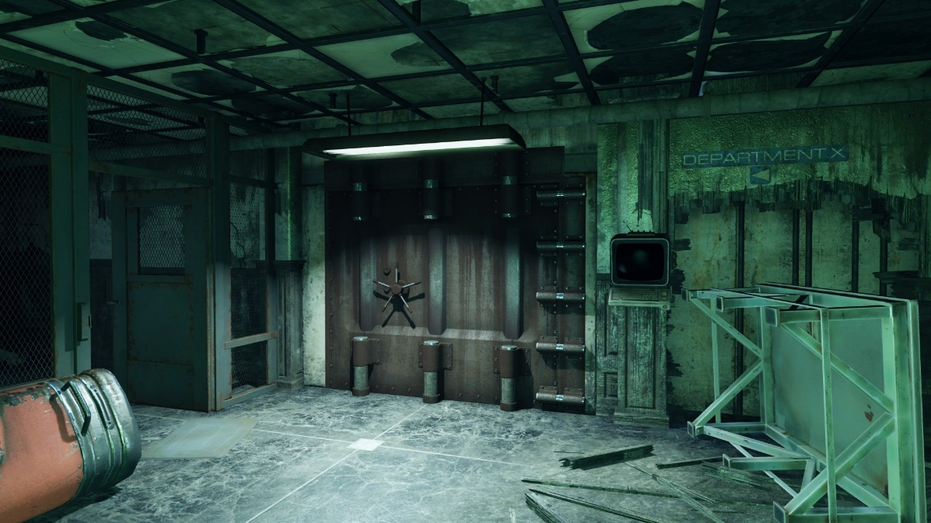

Figure : Visual Reference for Utility Tunnels [1]

*Fallout 4:*   
“Escape” (Title TBD)

Version 1.0

|  |  |
| --- | --- |
| Designer: | Jake Patton |
| Document Date: | 12/3/2017 |

**Document Revisions Table**

|  |  |  |
| --- | --- | --- |
| **Version** | **Description** | **Date** |
| 1.0 | Initial Document |  |
| 1.1 | Map Updates | 1/17/2018 |
|  |  |  |
|  |  |  |
|  |  |  |

# Table of Contents

Table of Contents 2

Table of Figures 2

Level Information 3

Level Goals 3

Quick Summary 3

Design Levers 4

Scene Table 5

Maps 6

Scene 1 6

Scene 2 10

Scene 3 12

Objective(s) 13

Hook(s)/Gameplay Highlights 13

Production Requirements 14

New Gameplay Mechanics 14

Development Schedule 14

Requirements 14

References 15

# Table of Figures

Figure 1: Visual Reference for Utility Tunnels [1] 1

Figure 2: Interior Level 1 6

Figure 3: Interior Level 2 7

Figure 4: Interior Level 3 8

Figure 5: Exterior Map Perspective 1 10

Figure 6: Exterior Map Perspective 2 11

Figure 7: Scene 3 Defensive Position 12

Level Design Document

# Level Information

## Level Goals

1. To demonstrate the application of my process for using Game Feel to align player interaction with game metaphor.
2. To create a *Fallout 4* of portfolio quality.

## Quick Summary

“Escape” is a single player level for *Fallout 4* in which the player attempts to escape from a raider camp inside of an old military hospital using a special set of pre-war power armor. To communicate the player’s arc, from confinement to power to their ultimate defeat, “Escape” uses my thesis process to align player interaction with game metaphor. In keeping with this, the level focuses on telling its story through the gameplay experience of the player rather than explicit narrative told through dialog. The player begins upstairs in the office wing of the hospital, armed only with a shotgun. They face hordes of Raiders as they descend to the plaza in front of the complex to activate the complex’s generator and escape through the rear. Unfortunately, when the player reaches the train station, their power armor is damaged and they are forced to face the raiders without it as they hold out for the gates of the compound to open.

## Design Levers

|  |  |  |  |
| --- | --- | --- | --- |
| **Verb/Level Design Element** | **Exposed Variables** | **Filter** | **Tone Shapes** |
| **Move** | Movement Speed | Control / Intensity / Freedom | Circle / Square |
|  | Game Speed | Intesity / Control | Circle / Triangle |
|  | Power Suit | Control / Freedom / Identification | Square |
|  | Level Openness (LD) | Freedom | Circle / Square |
| **Look** | Power Suit | Control / Freedom / Identification | Square |
|  | Number of Enemies (LD) | Intensity | Circle / Triangle |
|  | Amount of Cover (LD) | Intensity / Freedom | Square / Triangle |
|  | First / Third Person | Association / Control | Circle / Square |
| **Aim** | Power Suit | Control / Freedom / Identification | Square |
|  | Player Has High Ground (LD) | Control / Freedom | Circle / Square |
|  | VATs | Control / Intensity | Cicle / Square / Triangle |
| **Shoot** | Gun RoF | Control / Intensity | Circle / Square |
|  | Gun Damage | Control / Intensity | Circle / Triangle |
|  | Gun Feedback | Control / Identification | Circle / Triangle |
|  | Enemy Health (LD) | Freedom / Control / Intensity | Circle / Square |
| **Punch** | ? Player Strength ? | ??? | X |
|  | Power Suit | Control / Freedom / Identification | Square |
| **Survive** | Enemy Damage (LD) | Freedom / Control / Intensity | Circle / Triangle |
|  | Player Health / Availability of Health Items (LD) | Freedom / Intensity / Control | Square / Triangle |
| **Pick Up** | X | X | X |
| **Talk** | X | X | X |
| **"Interact"** | X | X | X |

Table : Fallout 4 Game Feel Lever Table

### Used Design Levers

* Power Suit
* Gun Type (RoF, Damage, Feedback)
* Movement Speed
* Number of Enemies
* Enemy Difficulty (Enemy Health + Damage)
* Amount of Cover

## Scene Table

|  |  |  |
| --- | --- | --- |
| Scene 1 | Scene 2 | Scene 3 |
| In Control / Constraint | In Control / Freedom | Constraint / Out of Control |

Table : Game Feel Filter By Scene

|  |  |  |  |
| --- | --- | --- | --- |
|  | **Levers** | **Call to Action** | **Rising Tension** |
| **Scene 1** | In Control / Constrained | Triangle | Square |
| **Scene 2** | In Control / Free | Circle | Circle |
| **Scene 3** | Out of Control / Constrained | Square | Triangle |

Table : Tone Shapes by Scene

|  |  |  |
| --- | --- | --- |
| Scene 1 | Scene 2 | Scene 3 |
| **In Control**   * low enemy damage + number + health * high player health * lots of cover * constant forward momentum through level   **Constrained**   * Small spaces * short range weapon * slow firing weapon * short lines of sight * lots of cover * use of flanking and choke point enemy placement patterns | **In Control**   * low enemy damage + health * high player health * high player movement speed * use of arena enemy placement patterns * high weapon range + damage * constant forward momentum through level   **Free**   * high player movement speed * use of arena enemy placement patterns * high weapon range + damage * low enemy cover * open spaces * long sight lines * fast level flow | **Out of Control**   * high number of enemies * low player health (lose power suit) * lower player movement speed * Use of stronghold and choke point enemy placement patterns * Low weapon damage * Stationary, wave-defense level structure   **Constrained**   * Stationary, wave-defense level structure * Low player movement speed * Use of stronghold and choke point enemy placement patterns * High enemy and player cover * Enclosed spaces * Short sight lines * Constrained level flow |

Table : Mechanics Modified by Scene

# Maps

## Scene 1

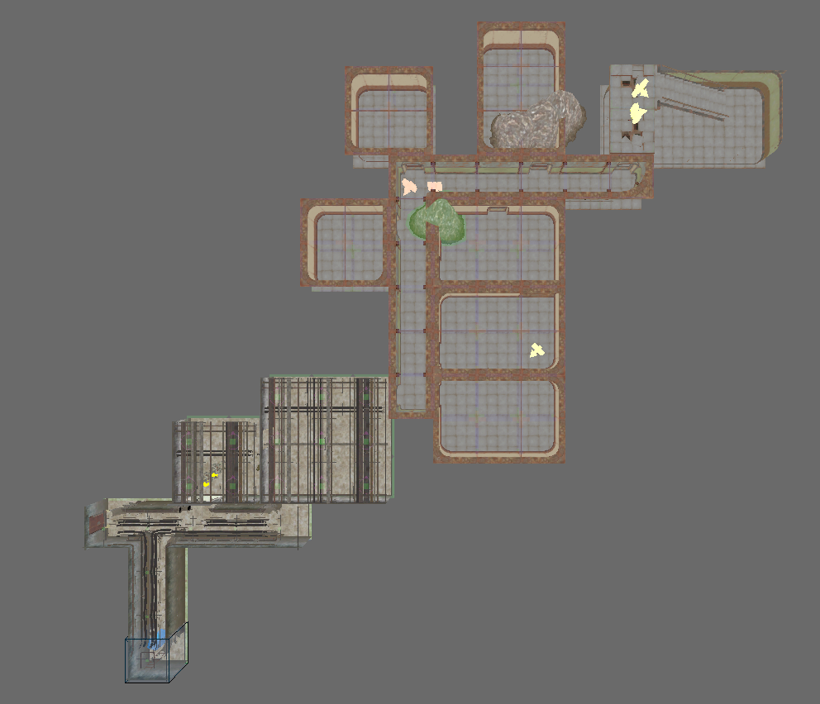

**B**

**A**

**3**

**2**

**1**

Figure : Scene 1 – Basement (Start)

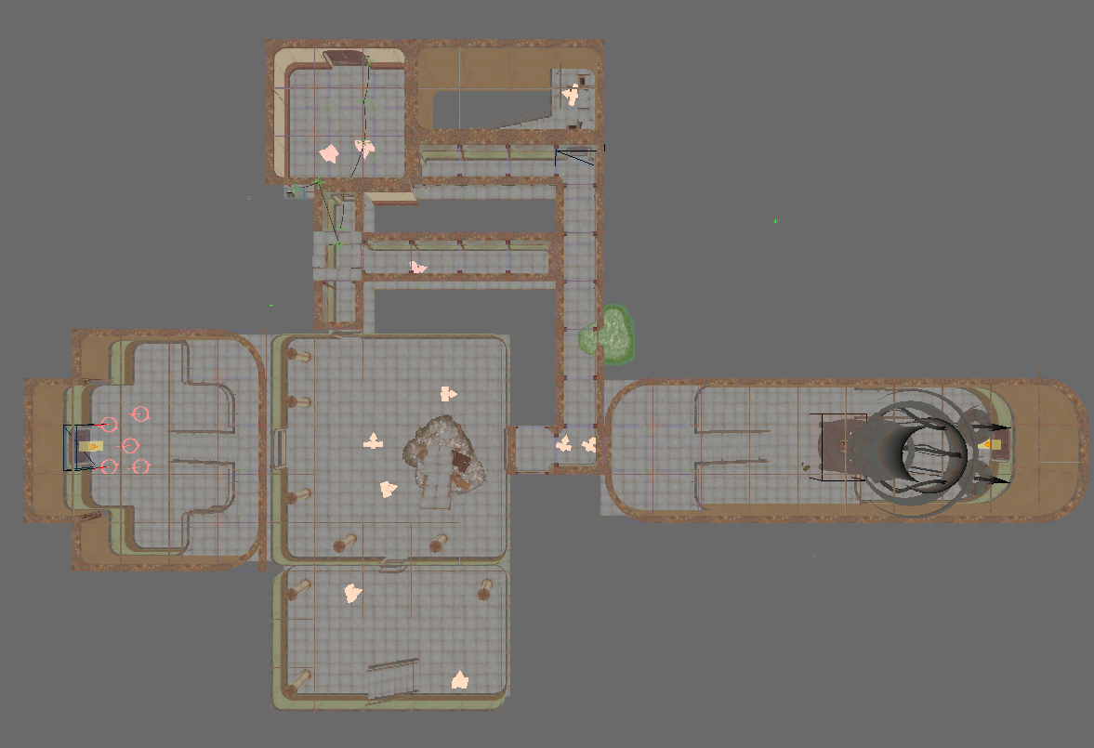

**C**

**9**

**D**

**8**

**5**

**4**

Figure : Scene 1 - Ground Level

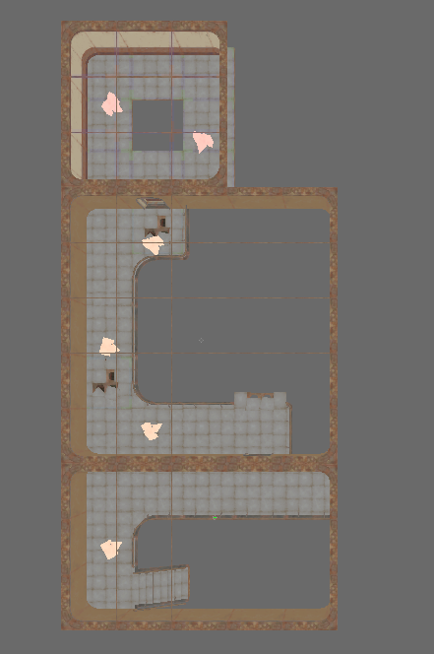

**D**

**7**

**6**

Figure : Scene 1 - Top Level

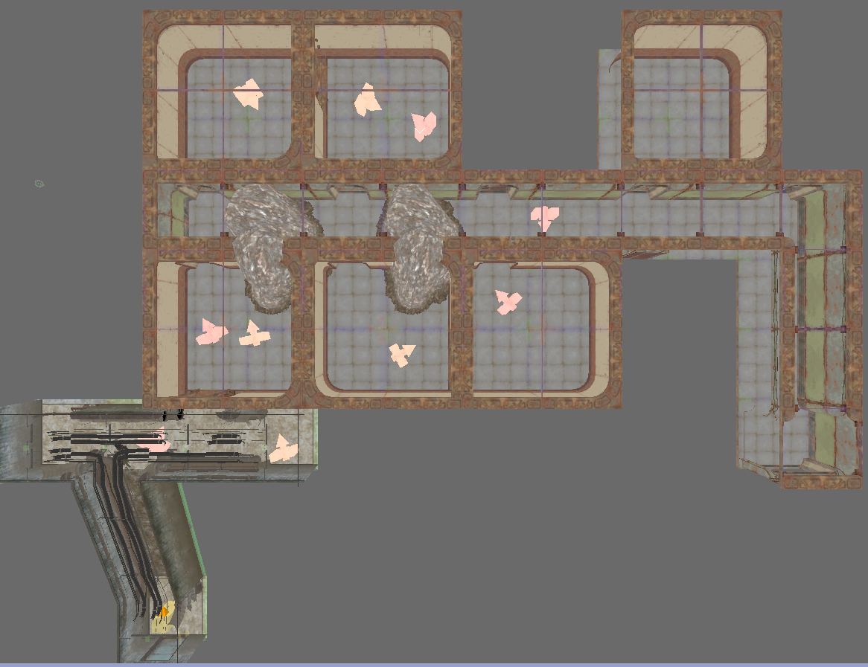

**11**

**10**

**E**

|  |  |  |  |  |
| --- | --- | --- | --- | --- |
| Map Label | Location Description | Detail Information | Approx. Time | Wow? |
| 1 | Player Starting Jail | Player begins level locked in a jail cell | 0:00 | No |
| 2 | Player Acquires Power Armor | Secret door (?) opens, player finds a pre-war set of power armor and a combat shotgun | 0:20 | Yes |
| 3 | Exit to 1st Floor | -- | 1:00 | No |
| 4 | Player Enters 1st Floor | Light and cover draws player to side door, sees objective (opening door to outside), as well as glowing wires leading away to one switches to open the door | 1:20 | No |
| 5 | To Top Floor | Wire leads player to large open room with ramp leading to second level | 2:00 | No |
| 6 | At Top Floor | --- | 2:10 | No |
| 7 | Flip Switch for Door | Find Terminal at end of wire. Interact to open door | 2:45 | No |
| 8 | Player Drops to Ground Floor | --- | 3:00 | No |
| 9 | Enter Side Area Through Door | --- | 3:20 | No |
| 10 | Find Laser Gatling | Player picks up Laser Gatling dropped by final enemy | 4:30 | Yes |
| 11 | Exit to Scene 2 | --- | 4:45 | No |

Table : Scene 1 Progression Summary

|  |  |  |  |  |  |
| --- | --- | --- | --- | --- | --- |
| Map Label | Encounter Name | Encounter Type | Detail Information | Approx. Difficulty (1-10) | Approx. Time |
| A | Initial Hallway | Choke Point / Flanking Route | Enemies at end of hall can be overcome by flanking through side rooms | 3 | 0:45 |
| B | Stair Assault | Stronghold / Hallway | Player fights a handful of enemies up two flights of stairs | 5 | 1:00 |
| C | Long Hallway | Choke Point / Flanking Route | Like initial hallway, but hallway is longer and flanking route is more dangerous | 4 | 1:15 |
| D | Two Floor Assault | Stronghold | Player fights up to high ground enemies | 5 | 1:45 |
| E | Tunnel Hallway | Hallway | Intentionally break design rule-of-thumb against single-direction enemy hallway to increase tension, final enemy has laser gatling | 6 | 3:20 |

Table : Scene 1 Encounter Summary

## Scene 2

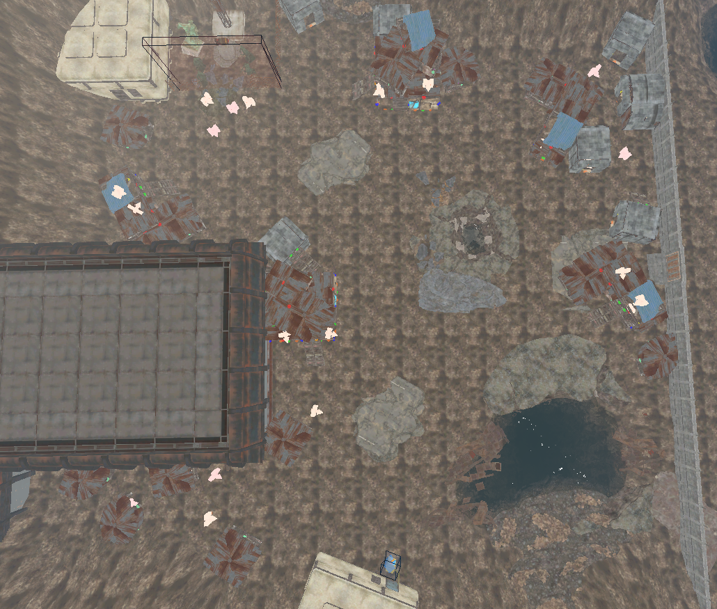

**B**

**A**

**3**

**2**

**1**

Figure : Scene 2 – Exterior

|  |  |  |  |  |
| --- | --- | --- | --- | --- |
| Map Label | Location Description | Detail Information | Approx. Time | Wow? |
| 1 | Exit to Exterior | --- | 5:00 | Yes |
| 2 | Center of Courtyard | Player goes to the center of the courtyard, fighting enemies, sees bomb | 5:45 | No |
| 3 | Getting Bomb | Player gets bomb, when exiting a trap destroys power armor | 6:45 | Yes |

Table : Scene 2 Summary

|  |  |  |  |  |  |
| --- | --- | --- | --- | --- | --- |
| Map Label | Encounter Name | Encounter Type | Detail Information | Approx. Difficulty (1-10) | Approx. Time |
| A | Open Field | Arena | Player has an incredibly powerful weapon but faces lots of enemies in an open area with clumps of cover | 4 | 5:30 |
| B | Defense of Switch | Arena, Stronghold | Enemies holding a defensive point near the final switch, relatively small numbers | 3 | 6:20 |

Table 6: Scene 2 Encounter Summary

## Scene 3



**2**

**A**

**1**

Figure : Scene 3 - Exterior



**C**

**B**

**5**

**4**

**3**

Figure : Scene 3 – Interior

|  |  |  |  |  |
| --- | --- | --- | --- | --- |
| Map Label | Location Description | Detail Information | Approx. Time | Wow? |
| 1 | Player Activates 3rd Switch | Player sees mass of raiders coming from gate, goes into door to interior | 7:00 | Yes |
| 2 | Entrance to Interior | --- | 7:30 | No |
| 3 | Player Brings Bomb to Defuser | Player follows marker to defuser | 7:45 | No |
| 4 | Player Defends Defusing Bomb | Player places bomb in the defuser, finds pistol and ammo, must defend against waves of enemies until the door opens | 8:30 | Yes |
| 5 | Player Exits | Player escapes, exits through the rear of the garage | 11:00 | Yes |

Table : Scene 3 Summary

|  |  |  |  |  |  |
| --- | --- | --- | --- | --- | --- |
| Map Label | Encounter Name | Encounter Type | Detail Information | Approx. Difficulty (1-10) | Approx. Time |
| A | Returning to the Hospital | Chokepoint | Enemies attacking the player from the settlement, forcing them into the interior | 4 | 7:00 |
| B | Back in the Interior | Flanking Route | A handful of enemies in the offices before the garage | 5 | 7:45 |
| C | Final Defense | Stronghold | See the wave composition | 7 | 8:30 |

Table : Scene 3 Encounter Summary

|  |  |  |  |
| --- | --- | --- | --- |
| Wave Number | Wave Composition | Approx. Difficulty (1-10) | Approx. Time |
| 1 | 3x Random Raider - Medium | 6 | 8:00 |
| 2 | 3x Random Raider – Hard | 7 | 8:30 |
| 3 | 3x Random Raider – Very Hard | 7 | 8:45 |
| 4 | 2x Random Raider – Very Hard 1x Boss Raider – Very Hard | 8 | 9:15 |

Table : Scene 3 Wave Composition (TBD)

## Objective(s)

* Defuse the bomb the raiders worship
* Survive

## Hook(s)/Gameplay Highlights

* Three distinct scenes, each with their own gameplay feel including
  + Claustrophobic corridor shooting
  + An open Gatling gun-focused area
  + A final defense section

# Production Requirements

## New Gameplay Mechanics

* Power Armor breaking down on command
* Slowly opening door (or some other countdown for the door)

## Development Schedule

|  |  |
| --- | --- |
| Milestone | Date |
| LDD | 1/22/2018 |
| Whitebox | 2/5 |
| Gameplay (Core) | 2/12 |
| First Test Run | 2/19 |
| Iterate on Feedback 1 | 2/26 |
| Second Test Run | 3/5 |
| Gameplay (Refined) | 3/19 |
| Aesthetics | 4/2 |
| RTM | 4/9 |

## Requirements

|  |  |  |  |
| --- | --- | --- | --- |
| Map Label | Description | Type | Priority |
| 2 (Interior) | Secret door | Scripting | Low |
| 2 (Exterior) | Enemy Attack Waves | Scripting | Medium |
| 5 (Exterior) | Destroying Power Armor | Scripting / Aesthetics | High |
| Scene 3 | Slowly opening door | Scripting | High |

# References

[1] <http://fallout.wikia.com/wiki/The_Switchboard>