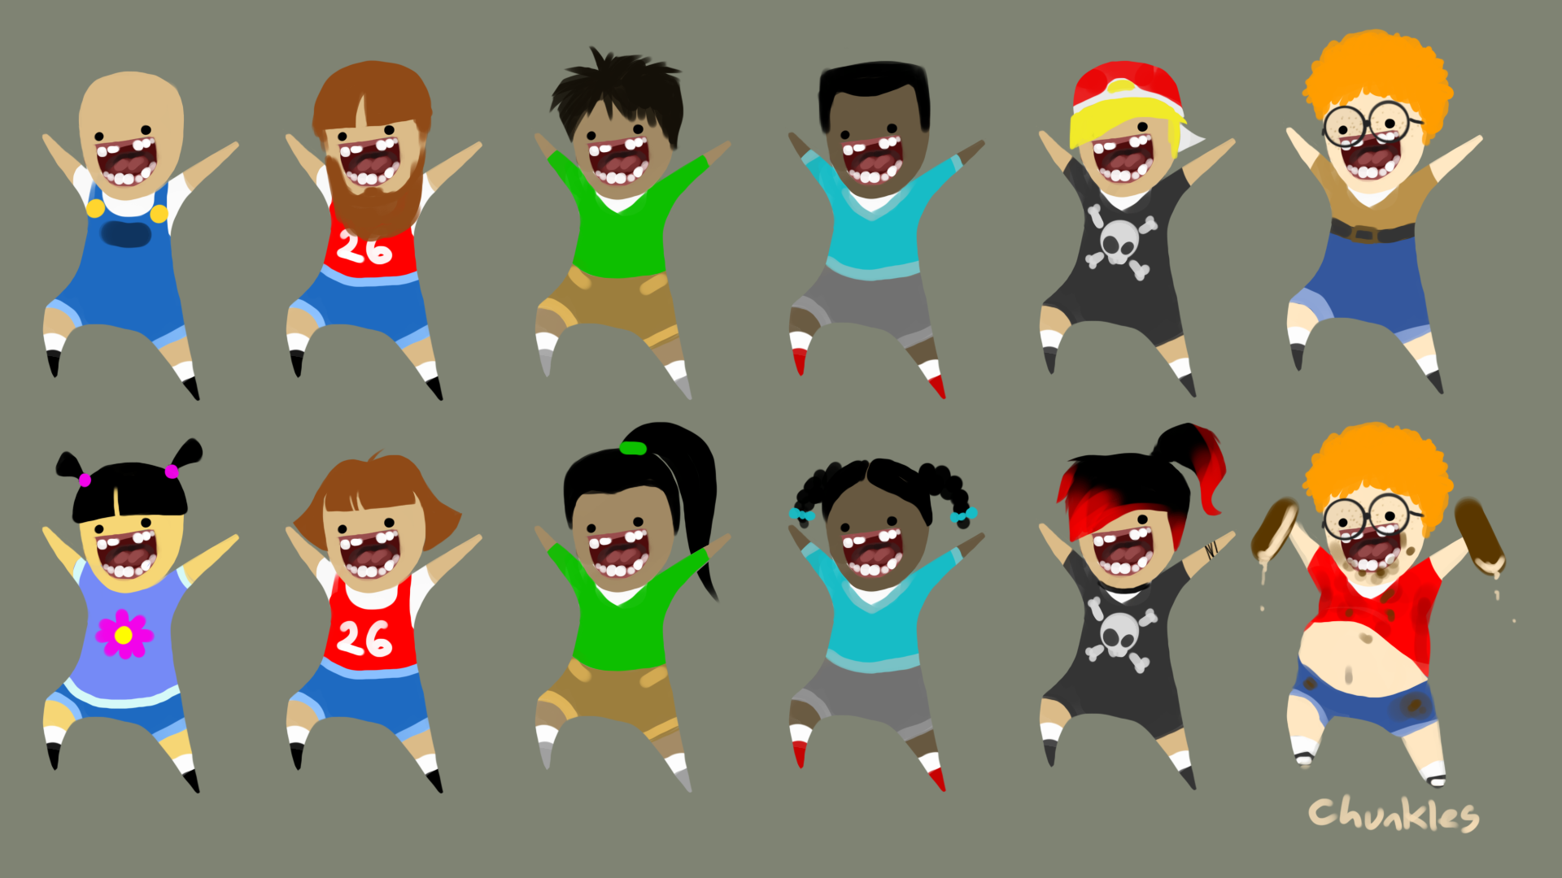

Up In the Air

Game Design Document

Table of Contents
Game Overview
High Concept
Game Pillars
Pure Comedy
Exaggerated Balloon Physics
Open Gameplay
Cartoon Hijinks
Gameplay Loops
Core Loop
Secondary Loop
Tertiary Loop
Risks
The Player
Player Avatar
Animations
Camera
Camera Metrics
Size Metrics
Basic Abilities
Run
Jump
Metrics
Balloon Boost
Effects
Metrics
Conveyance
Pick Up / Drop
Effects
Metrics
Conveyance
Power Ups
Overview
Power Up Pickups
Specific Pickups
General Pickups
Pickup Metrics
Unlocking Power Ups
Ground Pound
Effects
Metrics
Conveyance
Static Attraction
Effects
Metrics
Conveyance
Water Balloons
Effects
Metrics
Conveyance
Inflation
Effects
Metrics
Conveyance
Helium Push
Effects
Metrics
Conveyance
Controls
Keyboard
XBox Controller
Playstation Controller
Mass Table
Balloon Boost
Ground Pound
Air Push
Water Balloon
Death
Popping
Respawn Points
Metrics
Hazards
Children
Children Visual
Design Goals
Behavior
Types
Fans
Effects
Conveyance
Non-Movable Hazards
Effects
Types
Conveyance
Open World
Map / Layout
Open World Standards
Regions
Challenges
Tent/Arena Minigames
Basic Rules
Example Challenges
Arena Rewards
Reward Standards
Gameplay Bites
Basic Gameplay Bites
Collect a Thing
Example Gameplay Bites
Put a Thing in a Thing
Example Gameplay Bites
Remove a Thing from a Thing
Example Gameplay Bites
Go Inside a Thing
Example Gameplay Bites
Hit Something with Something
Example Gameplay Bites
Break a Thing
Example Gameplay Bites
Grow a Thing
Example Gameplay Bites
Signs
Objectives
Rewards and Progression
Currencies
Tickets
Tokens
Rewards
Shops
Skins
Consumable Items
Hot Dog
Ranch
Small Fan
Saber
Saving
Saving Functionality
State to Save
UI / HUD / Menu
Menus
Flow
Functionality
Options
Pause
Controls Splash
HUD
Information to Display
Transition Screens
Glossary
Adjustable
Movable Object
Relevant State
Toggle
Appendix A - Old Info
Picking Up Power Ups
Option One: Pickup Buttons
Option Two: Pickup Queue
Option Three: Slow-mo Balloons

Game Overview

High Concept
Up in the Air is a third person physics-based sandbox game in which the player controls a balloon dog explores an off-kilter carnival, avoiding children and collecting tickets.

Game Pillars

Pure Comedy
Our game should be judged based on its capacity to make the player laugh.

Exaggerated Balloon Physics
The player interacts with the world through over-the-top balloon pops,
bounces and springs.

Open Gameplay
The player is free to explore the carnival and overcome challenges whichever way they want to.

Cartoon Hijinks
The carnival is a cartoon world, with exaggerated proportions, movements, and physics.

Gameplay Loops

Core Loop
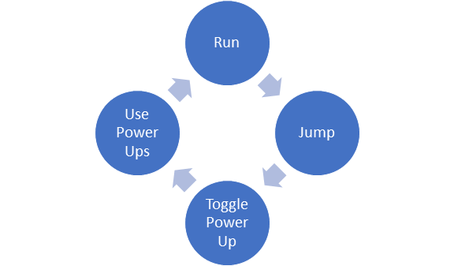

Secondary Loop
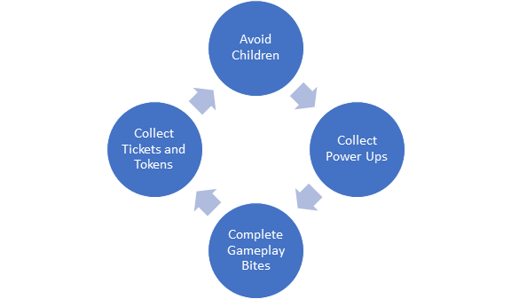

Tertiary Loop
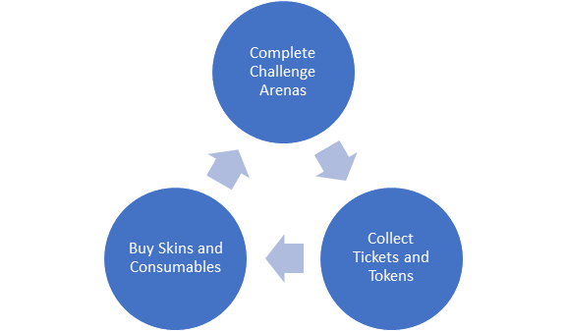

Risks
- Cross-Discipline
  - Incorporating mechanics into a solid gestalt game
  - Keeping a consistent and effective world scale
  - Juicing all aspects of the game
- Level Design
  - Making a good open world
    - That has enough stuff
    - That isn’t overwhelming
    - That the player can mentally map
  - Making a lot of minigames
- Programming
  - Might need to rework some of the physics system
- Art
  - Balancing bright carnival aesthetic with conveyance
  - Not as much time to make all assets because art needs to help LD

The Player

Player Avatar

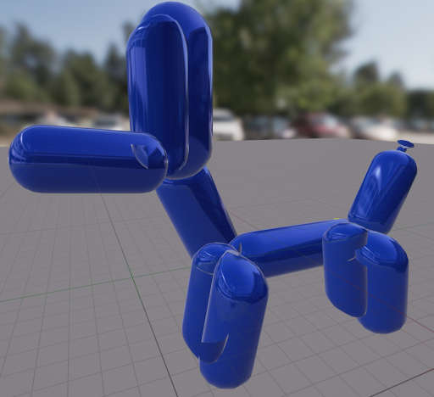
The default player avatar is a balloon dog.

Animations
The player is animated using a combination of simple, tweened poses and physics animations that deform movement based on obstacles and forces applied.
On the ground, the player has a simple, hopping walk animation, though this animation can be interrupted/deformed if the player collides with something
In the air, the player flaps their legs in a vain effort to change their direction while flipping in the air.

Camera
The player controls the pitch and yaw of the camera around their avatar. The camera follows the player. Small objects that come between the player and the camera become translucent. Large objects cause the camera to zoom in closer to the player up to a minimum distance

Size Metrics

Dog Dimensions (Unreal Units) | 64x245x194
Child Dimensions (Unreal Units) | 288x96x384
One Story Building Height (Unreal Units) | 800 with roof
Max Jumpable Height (Unreal Units) | 256
World Scale | 1 unit / cm
Physics-to-Animation Ratio

Basic Abilities

Run
The player can run along the ground by pressing the movement buttons. The player accelerates to max speed over a short period of time. Friction on the player is moderate-to-low: when the player releases the movement keys or changes directions, it takes a short time for them to stop or turn respectively.
In the air, the player can alter their trajectory using the movement buttons. The control the player has over their horizontal movement while in the air is much lower than on the ground.

Jump
The player can jump into the air while they are standing on the ground by pressing the jump button. The player has a variable jump height. The longer they hold the jump button, the higher they jump up to a maximum height.

Metrics
Acceleration | 1800
Max Movespeed | 1000
Ground Friction | 1.5
Air Control Ratio | 0.4
Jump Velocity | 750
Max Jump Time (Time from Ground to Ground) | 1.53
Max Jump Height | 312
Standard Jump Height | 256
Italicized metrics are references for artists and level designers, not adjustable values.

Balloon Boost

Effects
As the player uses Balloon Boost, they are pushed forward and deplete a boost resource. The player has access to Balloon by default and it is not bound to the normal power up keys. The ability has the following properties:
- The player can continue to use Balloon Boost until they run out of boost resource.
  - Boost resource recovers by an adjustable amount per second while the player is not using Balloon Boost. The amount is scaled down while the player is inflated.
  - The player loses an adjustable amount of boost resource per second while using Balloon Boost.
- While the player is in their deflated form, they “walk” forward (along the character’s forward vector, towards the character’s nose) at greatly increased speed
  - The speed multiplier is proportional to the amount of boost resource remaining
- While the player is inflated they are pushed in the direction the camera is looking
- The speed, acceleration, and air control modifier is adjustable

Metrics
Max Boost Resource | 1000
Boost Resource Recovery Per Second | 200
Resource Recovery Scalar (Inflated) | 0.5
Boost Resource Lost Per Second When Boosting | 1750
Speed Multiplier Max | 4
Speed Multiplier Min | 1.25
Acceleration Multiplier | 10
Air Control Modifier | 0.2
Boost Force Max (Inflated) | 12,000,000
Boost Force Min (Inflated) | 100,000
Boost Force Upward Scalar (Inflated) | .44

Conveyance
- A particle behind the player when using Balloon Boost
- A meter in the HUD indicating how much boost resource the player has
- A Sound when the player uses Balloon Boost that increases in pitch the less boost resource the player has

Pick Up / Drop

Effects
When the player picks up an object, it immediately moves and attaches to an adjustable point on the player avatar. The object retains collision. When the player drops the object, it immediately regains its physics properties.
To pick up an object:
- The object must be within an adjustable range of the player avatar
- The object must be within an adjustable raycast radius of the center of the player’s view (e.g. within an adjustable distance from the center of the player’s screen)
- The object must be a descendent of BP_BaseProp
- The player must press the (Pick Up / Drop) button
- If multiple objects meet these criteria, the player picks up the closest object to their avatar

Metrics
Pickup Range | 350
Trace Radius | 60
Pick-Up-Able Objects | BP_BaseProp

Conveyance
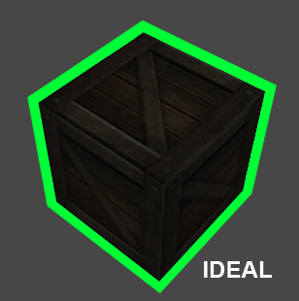
- An outline shader around the object which is currently targeted (i.e. is in range and in the view cone) for Pick Up

Power Ups

Overview
Power Ups are additional abilities that the player can access by picking up objects in the world. The player can have up to two Power Ups at one time, each bound to one
(Use Power Up) . The player can use their current Power Ups by pressing the corresponding (Use Power Up) button.
The player can hold Power Ups as long as the player has not picked up another Power Up and Power Ups persist through death.

Power Up Pickups
Power Ups are bound to objects in the game world, Power Up Pickups. When the player comes in contact with a Power Up Pickup, they can press one of their (Use Power Up) buttons to replace the Power Up currently bound to that button with the Power Up currently bound to the Power Up Pickup they are in contact with. The Power Up Pickup is not destroyed after the player switches their Power Up. Each pickup contains one Power Up. Each shop contains exactly one Power Up pickup of each type. Power Up pickups are only located inside shops.


Ground Pound

Effects
When the player uses Ground Pound, their movement is stopped and, after a delay, they drop to the ground. Ground Pound has the following effects:
- The player’s movement is stopped
  - For an adjustable time
- The player then drops to the ground
  - The player player is dropped quickly with an adjustable speed
  - The player cannot cancel this drop or move during it
  - When the player hits a surface
    - The Ground Pound drop stops
    - The player creates an explosion at the point of contact
      - That pushes away all movable (including the Player) objects in an adjustable radius
      - The push force is adjustable
      - The push force and radius scale between a minimum and maximum value based on the player’s time falling

Metrics
Stop In Air Time | 0.1s
Min Explosion Force | 1000
Max Explosion Force | 170,000
Min Explosion Radius | 600
Max Explosion Radius | 600
Drop Force | 1,500,000
Air Time to Reach Max Force | 2
Blend Method | Ease Out
Blend Exponent | 4

Conveyance
- A Sound when the player begins to Ground Pound
- A Sound when the player begins to drop to the ground
- A Sound when the player creates an explosion
- An explosion particle
- A particle on the player when dropping


Static Attraction

Effects
When the player uses Static Attraction, the following effects are toggled on and off:
- The player attracts a adjustable list of objects
  - Attraction strength is adjustable
  - Attraction range is adjustable
  - Attracted objects have an electricity beam particle between themselves and the player

Metrics
Attracted Objects | Balloons, Children, Tokens
Attraction Range (Unreal Units) | 1200
Attraction Force | 75,000

Conveyance
- A glowing static particle effect on the player when the static effect is toggled on
- An electric beam particle between the player and each attracted object
- A Sound for when static is turned on
- A Sound for when attracting stuff
- A Sound for when static is turned off

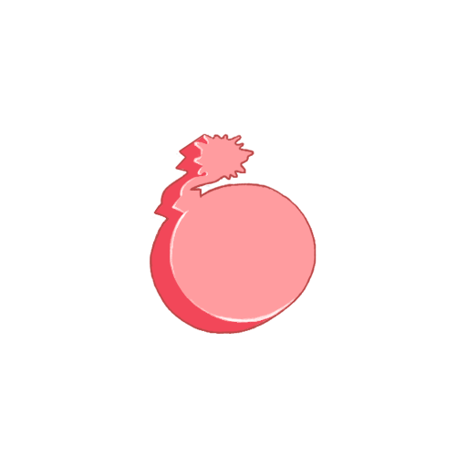
Water Balloons

Effects
When the player uses Balloon Bombs, the player spawns a Balloon Bomb with the following properties:
- The Balloon Bomb is a persistent object that lasts for a adjustable amount of seconds
  - The Balloon Bomb can be picked up and dropped.
  - The Balloon Bomb can be affected by other power ups.
  - The Player can only have an adjustable number of balloon bombs in the world at a time
    - When the player spawns a balloon bomb over the maximum allowed the first bomb
  - The Balloon Bomb is destroyed when:
    - It collides with the player while the player is Balloon Boosting
    - It collides with a child
    - When, during a hit event, an impulse applied to the Balloon Bombs is over an adjustable threshold
    - When the Balloon Bomb is within the explosion radius of another Balloon Bomb
  - When the Balloon Bomb is destroyed:
    - It pushes all movable objects in a sphere centered on itself away from itself
    - Sphere radius is adjustable
    - Push strength is adjustable

Metrics
Bomb Maximum Life | 240 seconds
Contact Radius | 128
Objects that Trigger Explosion | Player, Children, Balloons
Explosion Radius | 400
Explosion Force | 40,000
Time Until Active | 0.5
Hit Impulse Threshold | 40,000
Max Balloons | 10

Conveyance
- Balloon Bomb model
- A Sound when dropping a mine
- A Sound when the mine explodes
- Particle effect on the player when they have the Balloon Bomb Power Up
- Particle effect for the Balloon Bomb explosion

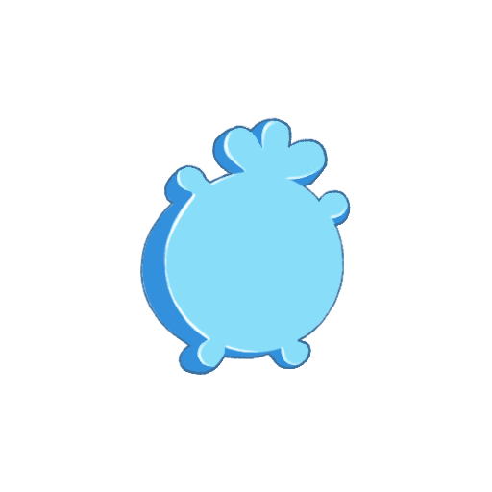
Inflation

Effects
When the player uses Inflation, the following effects are toggled on and off:
- The player’s model is changed to an over-inflated version
  - The player has and adjustable, greatly reduced gravity
  - The player has adjustable, greatly increased bounciness
  - The player can no longer run along the ground
  - The player’s air control is greatly reduced by an adjustable amount

Metrics

Balloon Gravity Scale | 0.6
Coefficient of Restitution | 0.9
Push Force on Movement | 0

Conveyance
- A Sound when toggling the inflated state on and off
- A Sound when bouncing off objects/surfaces
- A different, over-inflated player model
- A bouncing material that “jiggles” when the player bounces

Helium Push

Effects
When the player uses Helium Push, the player pushes all movable objects in a cone in front of them away from them.
- The Helium Push Cone
  - Emanates in a single instantaneous burst
  - Has a short, adjustable cooldown before it can be used again.
  - Emanates from the player model’s mouth area
  - Has an adjustable cone angle (full angle edge to edge centered on player forward vector)
    - The angle of the conveyance effect should be smaller than the actual effective cone angle, to avoid edge cases where objects appear to be affected but are not
  - Has an adjustable range
  - Pushes all moveable objects in the cone with an adjustable force forward in the direction the player is facing
  - Pushes all moveable objects in the cone with an adjustable force upward.
    - These two forces are separately adjustable

Metrics

Cone Angle | 45°
Cone Range (Unreal Units) | 600
Push Force | 300,000
Cooldown | 0.5 seconds

Conveyance
- A squeaky Sound when moving and colliding with an object with the power up
- A Sound when push an object or objects
- A particle on the player when having the power up
- A particle for the Helium Push cone
- A particle on objects pushed by the cone

Controls

Keyboard

Move | W-A-S-D
Turn Camera | Move Mouse
Jump | Space
Balloon Boost (Base Ability) | Shift
Use/Pick Up Power Up 1 | Q
Use/Pick Up Power Up 2 | E
Pick Up / Drop | Left Click
Pause | P
Buy | R

XBox Controller
Move | Left Analog Stick
Turn Camera | Right Analog Stick
Jump | A
Balloon Boost (Base Ability) | B
Use Power Up 1 | Left Trigger / Shoulder
Use Power Up 2 | Right Trigger / Shoulder
Pick Up / Drop | X
Pause | Start
Buy | Y

Playstation Controller
Move | Left Analog Stick
Turn Camera | Right Analog Stick
Jump | X
Balloon Boost (Base Ability) | Circle
Use Power Up 1 | L2
Use Power Up 2 | R2
Pick Up / Drop | Square
Pause | Start
Buy | Triangle

Mass Table

Balloon Boost
Mass | Distance Travelled (cm)
25 kg (Light) | 2400
50 kg (Standard) | 1500
100 kg (Heavy) | 400

Ground Pound
Based on a Ground Pound executed from the apex of a normal jump.
Mass | Distance Travelled (cm)
25 kg (Light) | 16,400
50 kg (Standard) | 4000
100 kg (Heavy) | 1600

Air Push
Mass | Distance Travelled (cm)
25 kg (Light) | 20,400
50 kg (Standard) | 5000
100 kg (Heavy) | 1700

Water Balloon
Based on the explosion of one balloon bomb.
Mass | Distance Travelled (cm)
25 kg (Light) | 3700
50 kg (Standard) | 700
100 kg (Heavy) | 150

Death

Popping
Hazards and children can pop the player. After popping, the player is respawned at the last respawn tank they activated after a short delay. During this delay, the camera lingers on the player to show the aftermath of their explosion
The player does not lose currency or Power Ups when they pop. Popping is intended to be only slightly punishing.
When the player pops they:
- Explode:
  - Pushing back all movable objects in an adjustable radius
  - The push force of the explosion is adjustable
  - The explosion creates a particle
  - The explosion plays a sound

Respawn Points
Respawn points are helium tanks scattered through the world. When the player dies, they spawn at the nearest respawn point. Respawn tanks should not be visually arresting.

Metrics

Respawn Delay Time | 2 seconds

Hazards

Children

Children Visual

Design Goals
- Children feel zany and hilariously stupid
- Childrens’ behavior is easily predictable
- Children have enough freedom in their behavior so that design can make diverse challenges with them

Behavior
- Detect the player
  - Not through walls
  - Arc of detection and detection range adjustable
- Detect other objects
  - Not through walls
  - Arc of detection and detection range adjustable, same as player
  - Priority for each object and player adjustable
- Chase a target object (player or other)
  - Not run into walls
  - Has a adjustable de-aggro boarder, at which they will return to their previous activity
  - Speed of chase adjustable
- Multiple actions once they reach the chased object
  - Kill (pop)
  - Kick away
  - Grab / Attach
  - Action taken adjustable per target object (player, other object)
- Patrol
  - Walk between a predetermined set of nodes when not chasing an object
  - Return to the patrol when there is nothing to chase
- Idle Wander
  - Randomly wander a predetermined capsule volume while not chasing an object
  - Return to the Idle zone when there is nothing to chase
- “Fall State”
  - Ragdoll when dropped, thrown, or exploded at high speed
  - Ragdoll until hitting the ground
  - After hitting the ground, stay in ragdoll for a adjustable amount of time
  - After ending ragdoll, clear chasing queue
    - If finds a new target, chase it
    - Otherwise return to original behavior

Types

Easy
Priorities: Hotdogs > Props > Player
Actions: Destroy > Carry > Kick

Medium
Priorities: Hotdogs > Player > Props
Actions: Destroy > Kick > Kick
Conveyance: Must wear head gear

Hard
Priorities: Hotdogs > Player > Props
Actions: Destroy > Destroy > Carry
Conveyance: Must be holding a spike-y object and wear a large piece of head gear

Fans
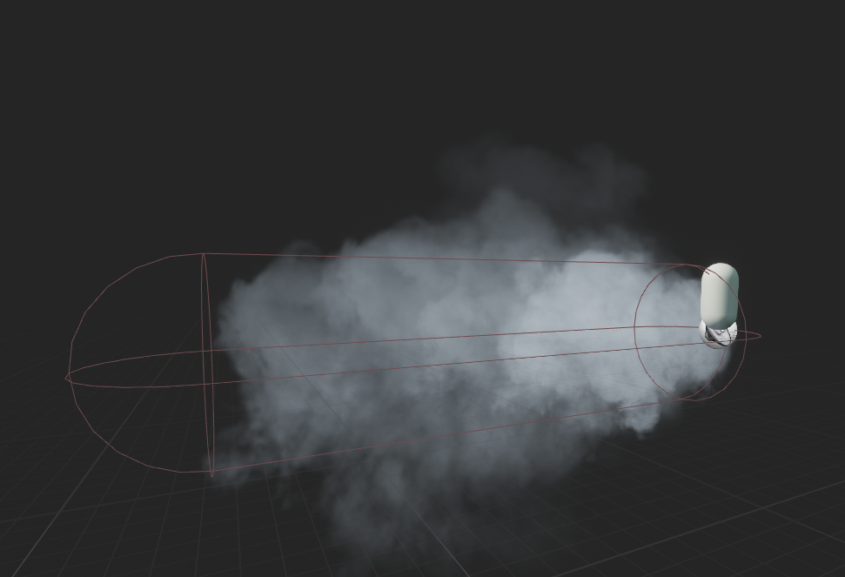

Effects
Fans push all movable objects in a capsule directed away from them.
- Capsule radius is adjustable
- Capsule length is adjustable
- Push force is adjustable
  - Push force decreases linearly as the player moves away from the fan object

Conveyance
- Fan model with animation of the fan rotating
- A Sound that gets louder as the player moves closer to the fan
- A Sound that plays when an object is pushed by the fan
- An air particle indicating the area the fan affects

Non-Movable Hazards
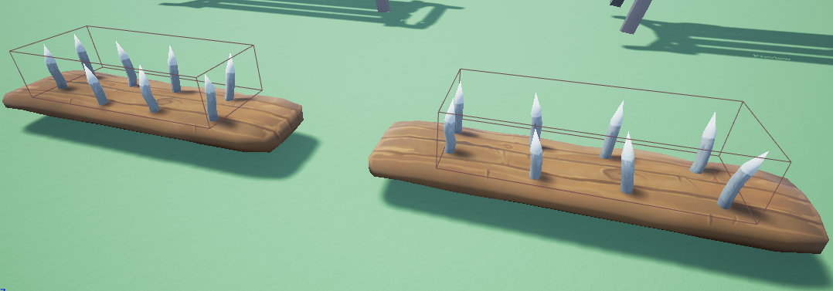

Effects
- On contact instantly pops the player.

Types
- Grounded Hazards:
  - Spikes
  - Cactus

Conveyance
- Non-Movable hazard models must look sharp
- The instant-death area must be slightly smaller than the visual representation
  - So that the player has some forgiveness
- Non-Movable hazards must visually contrast with the surrounding area

Open World
The player begins each level in a large and open sandbox map set in a small, rundown theme park. There are 4 different distinct areas of the theme park, separated into themes (Carnival, Wild West, Medieval). There are a multitude sub-objectives, easter eggs, children, hazards, power-ups and collectibles in this sandbox area. The player can interact with these elements at their leisure. Within the open sandbox area, the player can find challenge tents which are large carnival tents with a door that leads to a separate area. Challenge Tents contain structured challenges that test the player’s skill with a specific mechanic or mechanics and contain a collectible reward the player can access if they complete the challenge.

Map / Layout

Open World Standards
The open world is littered with gameplay bites and interactions for the player. The world should reward exploration with tokens in secluded or hard to reach areas. If the player can see something interesting in the park, they should be able to get there directly and there should be something for the player to do there. Buildings as a general rule cannot be entered but can be landed and walked on top of.
Each region should have
- 1 Challenge Arenas
- 15+ ways to earn tickets
- 1-2 small shops to spend tokens (if that is the direction the game goes)
- 1 Weenie
- Things that the player can climb on top of
- Set roads to help with orientation and guiding new players
- 3+ respawn tanks

Region Design Goals

Carnival:
This area is very similar in look and feel to your average carnival that happens at a park. It also serves as the starting area for the player and is the region where the the average player feels safest. The layout should be very clear and distinct so that the player learns the are very quickly. Whenever a player returns to the carnival area, it should feel familiar and they should know where they are in it. Gameplay bites and challenge tents found in this region are some of the easiest and most fun in the game. The tent and area where the player can spend tickets on large rewards is found here.

Wild West:
This region should be the region that the player is drawn to second, after leaving the carnival area. It is fairly easy to navigate and learn the layout of. Gameplay bites and challenge tents are of medium difficulty. Cactuses are the first gameplay element that can pop the player but are stationary and not overly dangerous.
Medieval:
The medieval region is the furthest region from the start of the game and has the most difficult yet most rewarding challenge tents and gameplay bites. There are still simple and easy gameplay bites but the medieval has the highest rate of difficult challenges. The medieval section has a lot of trees and ⅓ of it is a forested area. T It should reward exploration and have random fun things for the player to find.

Challenges

Tent/Arena Minigames
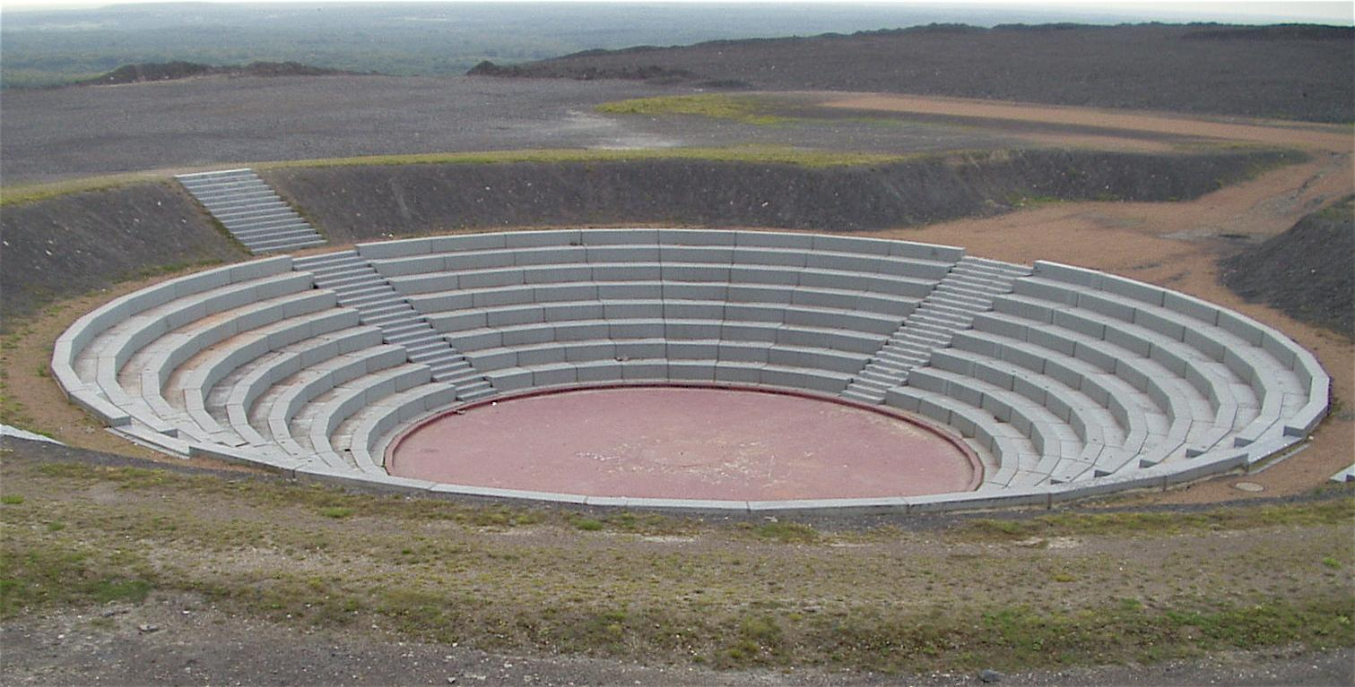

Basic Rules
- Arenas are in the open world
- There is one arena per region, but all arenas use the same art assets
- Arenas can be seen from many sight lines but are sunk into the ground
- Each challenge arena has a Respawn Tank at the beginning
- Each challenge arena has a reward
- Arenas are unlocked with a large amount of tokens
- Arenas have three tiers of rewards, depending on how well the player completed the arena challenge. Each tier gives a different level of reward.
  - Tier 1: Ticket(s) || Tier 2: Skin Color || Tier 3: Skin
- The player can only earn each tier of reward once.
- All skin rewards will also be purchasable with tickets.
- If the player has already purchased the Skin they receive as a reward for completing the third tier of the challenge arena, they are rewarded with tokens at least double the value paid to unlock the arena.

Arena Rewards
- Tier 1:
  - Ticket(s)
- Tier 2:
  - Skin Color (Material)
- Tier 3:
  - Skin

Reward Standards
- The player can only earn each tier of reward once.
- All skin rewards will also be purchasable with tickets.
- If the player has already purchased the Skin they receive as a reward for completing the third tier of the challenge arena, they are rewarded with tokens at least double the value paid to unlock the arena.

Gameplay Bites
Gameplay bites are an integral part of providing enough gameplay for the player. They provide tickets for the player that they can use to purchase rewards, but even more they should feel satisfying or rewarding within themselves. There should be some sort of communication to the player that the gameplay bite exists and how they should do it. It could be something as subtle as a soccer ball and a soccer goal naturally going together, or could be something more direct like a sign telling the player that they could do the gameplay bite.
There are two kinds of gameplay bites, basic bites, and hero bites. Standalone bites are context-heavy, intricate, and should be found only once in the park. These ones almost always give a ticket as a reward.
Basic bites are generic enough to be modifiable to fit wherever they are in the park without much hassle and usually give tokens as a reward. If the effect of a reusable gameplay bite causes the bite itself to be destroyed or otherwise rendered un-reusable (boards are exploded, there are no more items to use for the bite, etc), then the bite should remain un-reusable until the player has reloaded the level. If the bite is not destroyed or rendered un-reusable after it is completed (kicking a soccer ball into a goal), the player should only receive one token for completing the bite again until the level is reloaded.

Basic Gameplay Bites
There are nine basic gameplay bites. These are essential gameplay forms that can be reused and remixed into multiple forms. These bites are:

Collect a Thing
The player must collect a certain number of objects scattered throughout an area. After collecting all objects, they get a ticket.
The player collects an object by moving into it. After the player moves into the collectable object, it is destroyed and their collection count is increased by one.
The objects that can be collected in surrounding area, as well as the player’s current collection count is displayed in the player’s objective list.

Example Gameplay Bites
- Find four gold stars in each region
- Find one dinosaur in each region
- Jump along the rooftops to collect all large tokens

Put a Thing in a Thing
The player must bring a specified object or objects and place it inside a specified area.

Example Gameplay Bites
- Push a soccer ball into a soccer goal
- Put a kid in jail
- Herd sheep into a pen

Remove a Thing from a Thing
The player must push a specified object off a specific area or location.

Example Gameplay Bites
- Knock over bowling pins
- Push a kid out of a sumo ring
- Knock over a trash can

Go Inside a Thing
The player must run into and/or through a specified area or object.

Example Gameplay Bites
- Run through a hay bale
- Run through a bush
- Fall into a cave

Hit Something with Something
The player must cause a specified object to hit another specified object.

Example Gameplay Bites
- Hit a kid with a laser sword
- Hit a castle with a cannonball

Break a Thing
The player must break an object by boosting into it, exploding it with bombs, hitting it with the Helium Push, or ground pounding.

Example Gameplay Bites
- Break boards
- Break barrels

Grow a Thing
The player can grow objects by putting them in a specified area and walking over a button. The object can only be grown one time. Growing an object increases its scale by 2x.

Example Gameplay Bites
- Grow ray in a lab in the space area
- A farm in the medieval area.

Signs
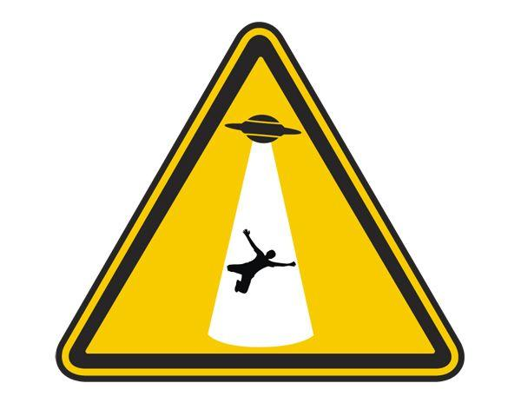
Most gameplay bites should have a corresponding warning sign (see above for reference) that depicts the state in which the gameplay bite is complete. For example, if the player needs to lead a child into a UFO, the warning sign should depict a child being levitated into a flying saucer.
A gameplay bite should have a sign if it meets one or more of the following conditions:
- The bite requires multiple steps to complete (like putting three sheep balloons in a pen)
  - This type of gameplay bite should provide feedback for each partial step
- The bite requires the player to affect an object indirectly (like leading children onto a button)
Gameplay bites do not need a sign if they meet the following conditions:
- The bite is intended as a secret or easter egg
- The bite has large amounts of affordance (a soccer ball and soccer net next to each other)

Rewards and Progression

Currencies
The player’s main moment-to-moment objective is to acquire collectables throughout the world. The two main collectables are Tickets and Tokens.

Tickets
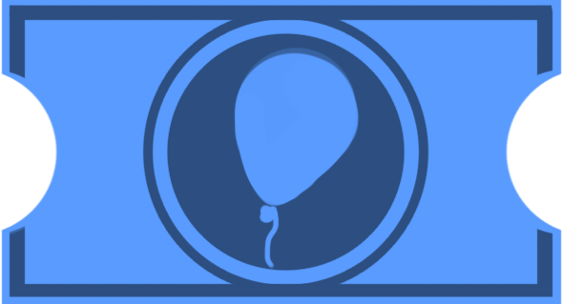
Tickets are the rarer currency, a reward for completing Gameplay Bites and Arenas
Once the player collects a Ticket, they cannot collect the same Ticket again; Tickets do not respawn.
The player can use Tickets to unlock new power ups and skins for the player. Collecting all tickets is the player’s final challenge.
When the player receives a ticket, if they have enough to buy a new power up, a pop up appears on screen with text and icons indicating the power up that they can purchase.

Tokens
Tokens are a common, respawning currency used to guide the player through levels
Tokens respawn after some time. There is no limit to the number of tokens the player can collect.
The player can use Tokens to buy consumable items.

Rewards

Shops
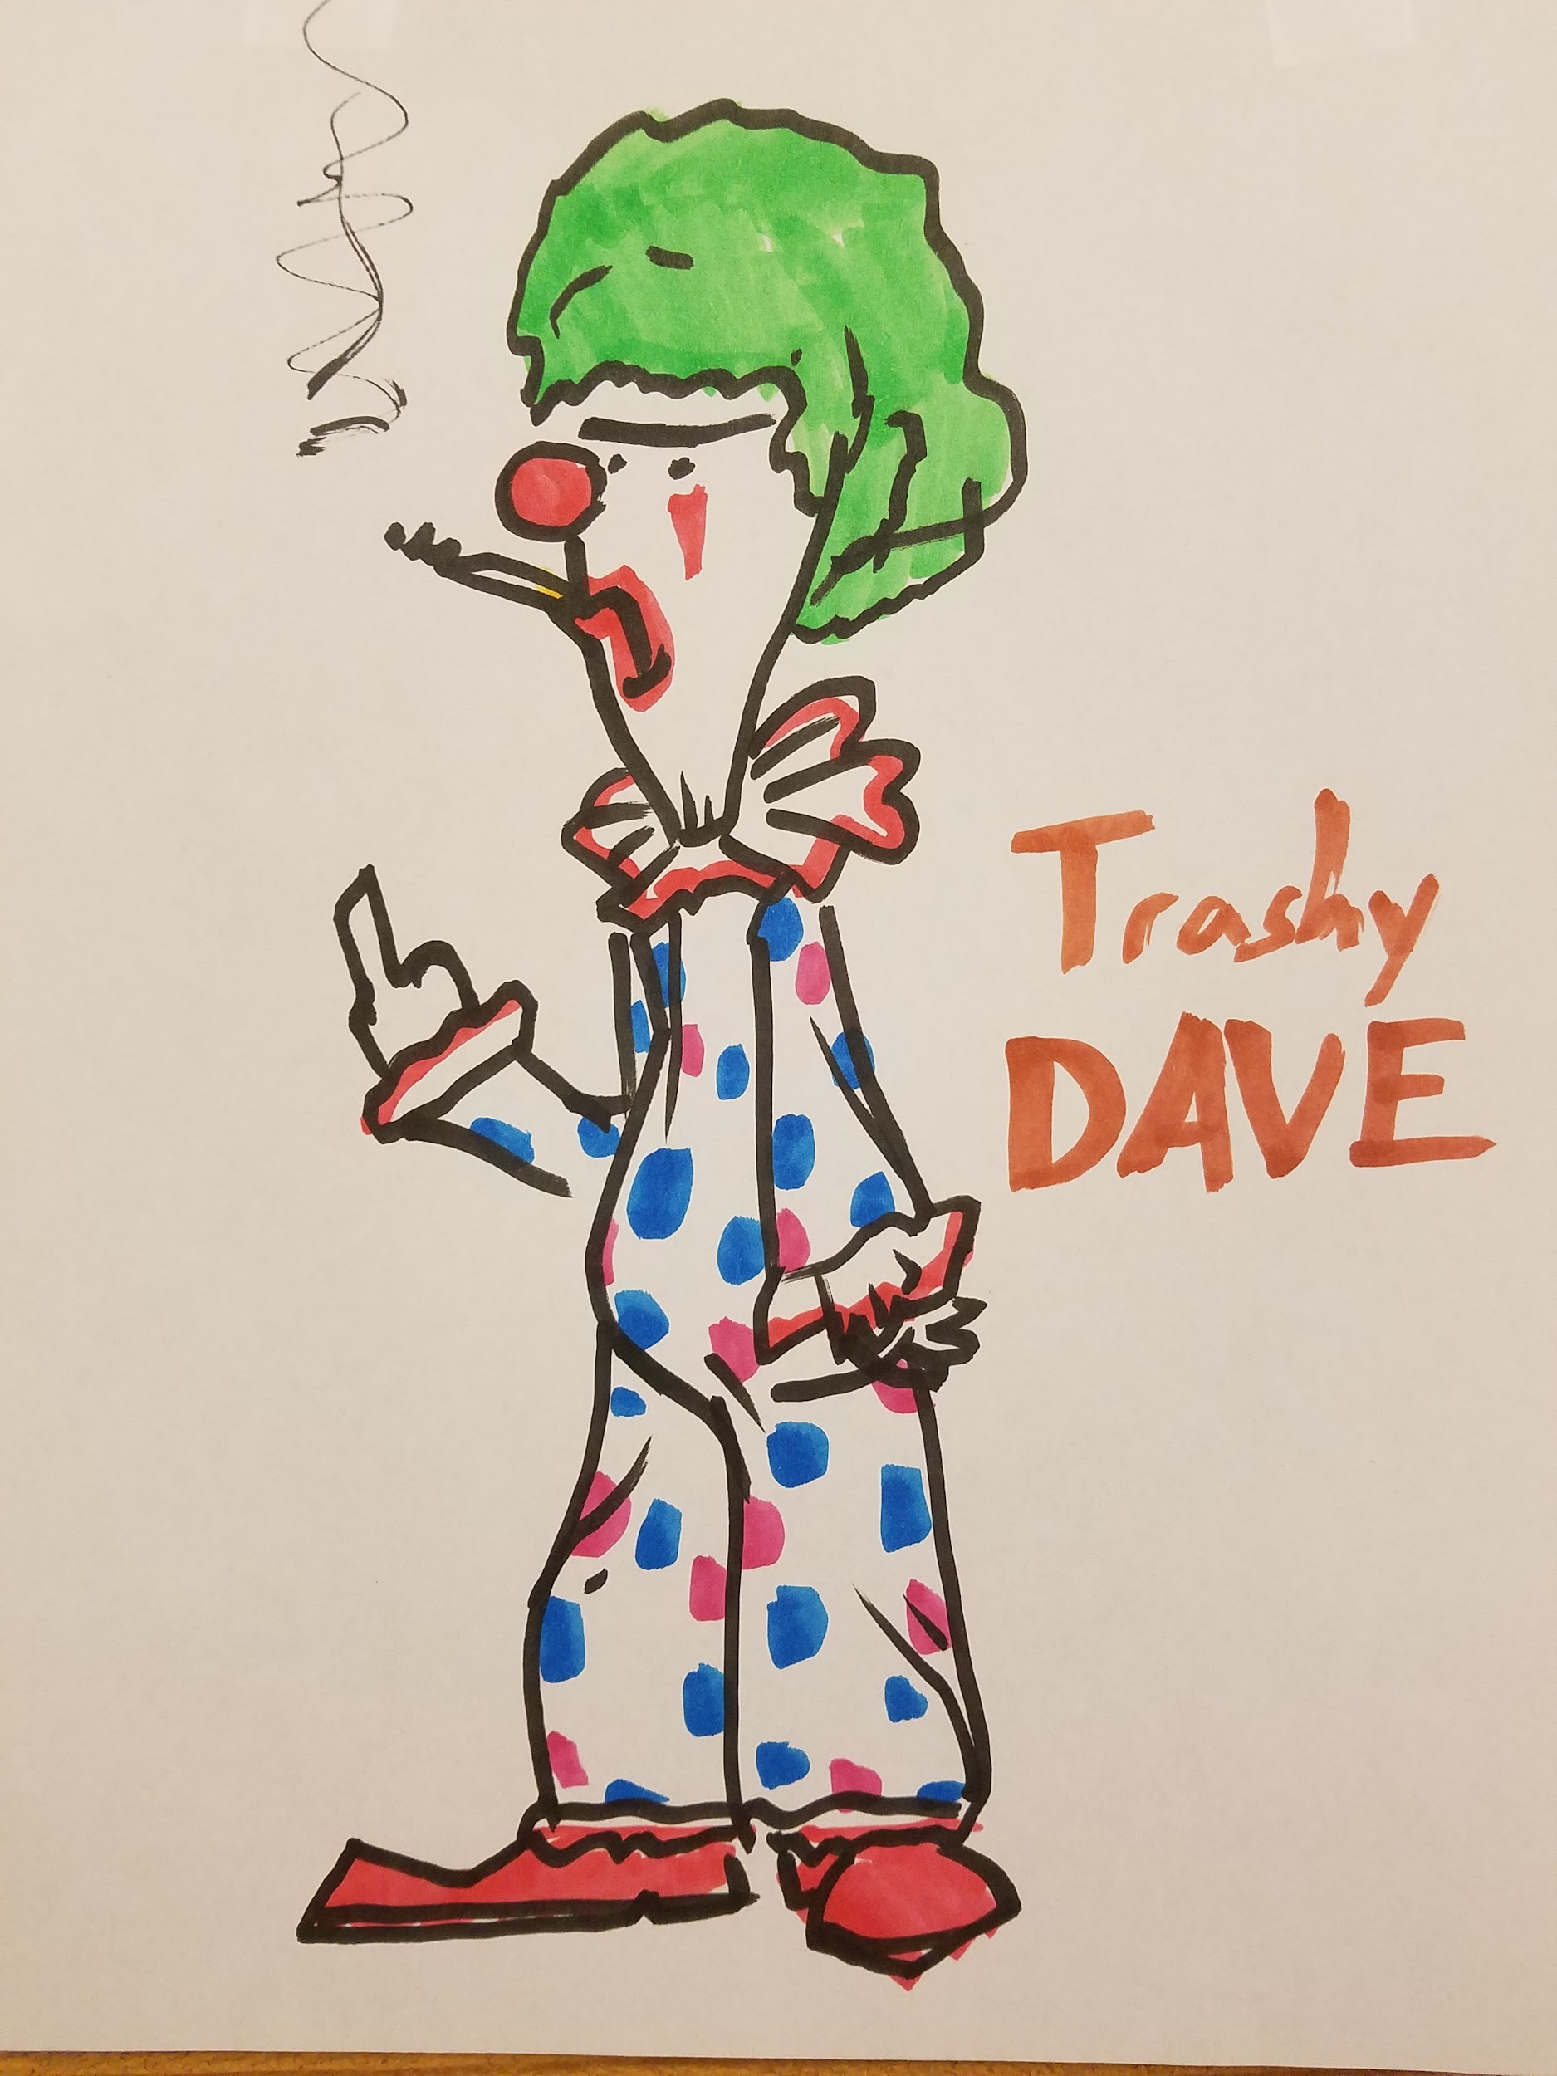
Players can turn in Tickets and Tokens at shops, scattered throughout the world to purchase permanent rewards like Power Ups and Skins and consumable rewards like Hotdogs respectively. These shops are stationary. Each shops sells every power up, as well as a suite of consumable rewards and one skin.

Skins
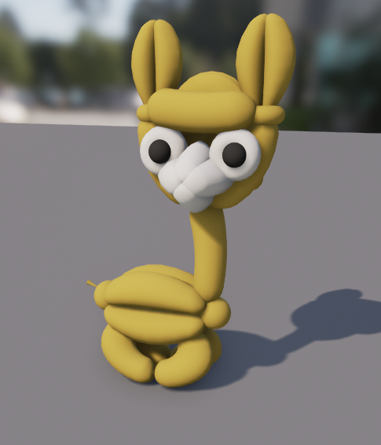
An alternate texture for the player avatar.
- Skins must not convey that the player has any additional abilities or characteristics.
  - EX: A bird skin would not be possible because it would convey that the player could fly.
- Skins must stand out from the environment and cannot be light green or brown.

Skin List
Skin Name | Price | Default? | Arena Reward? | Easter Egg?
Red Rover | 0 | Yes | No | No
Steel Shetland | 16 | No | No | No
Power Pup | 10 | No | No | No
Arachno Akita | 0 | No | Yes | No
Murica Mastiff | 0 | No | Yes | No
Hot Dog | 18 | No | No | No
Dalmatian | 12 | No | No | No
Golden Retriever | 0 | No | Yes | No
Radioactive Rottweiler | 0 | No | No | Yes
Invisible Whippet | 0 | No | No | Yes

Power Up Prices

Power Up | Price
Static | 2
Ground Pound | 4
Air Blast | 6
Water Balloons | 8
Inflated | 10

Saving

Saving Functionality
- One save slot
- Autosaves whenever relevant state changes
- Save slot can be cleared to reset game to initial state
- On load, only relevant state is set to match saved state, all other set is returned to initial state

State to Save
- The player’s active Power Ups
- The currently active respawn tank.
- The number of Tickets and Tokens the player has
- Which Tickets the player has picked up, which should no longer exist
- Which Objectives the player has completed

UI / HUD / Menu

Menus

Flow
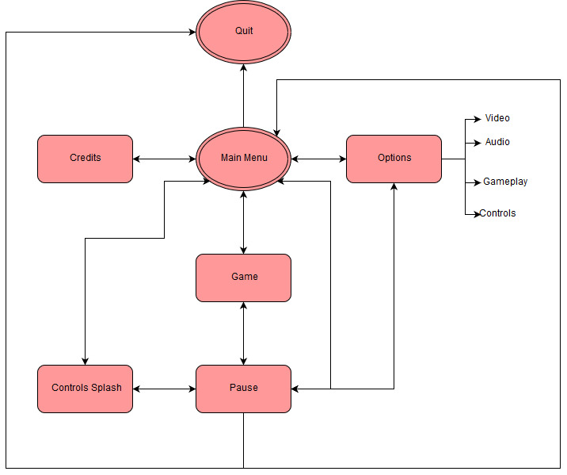

Functionality

Options
- Video
  - Resolution
  - Full Screen
- Audio
  - Volume Sliders
    - SFX
    - Music
    - Voice
    - Master
- Gameplay
  - Invert Y
  - Look Sensitivity
- Controls
  - Keybindings
- Reset Progress (With confirmation pop-up

Pause
- Pause menu opens when the player presses the (Pause) button
- Pauses all action in the game, arresting all physics and interactions
- Allows access to options, control splash, main menu, and to quitting the game

Tips and Tricks
- All the in-game tips are collected here and can be viewed after the player has lev

HUD

Information to Display
- Always Shown On Screen
  - Which Power Ups the player has
    - An icon on the top left and right of the screen
- Only Shown When
  - How many Tickets and Tokens the player has
    - An icon and number in the bottom right of the screen
    - Only appears when the player picks up these currencies
      - Fades after a short time
    - For tickets, indicates the maximum number of tickets in the game
  - Any Objectives active in the player’s current area
    - Possibly {Text in the bottom left of the screen?}
    - Only appears if an objective is active

Transition Screens
- Must having a moving element
- Must cover the entire screen
- Should have an element of comedy / a joke / a funny image

Glossary

Adjustable
Indicates the the following value is an exposed variable that can be adjusted in editor.

Movable Object
Either an active character (such as a child) or a non-static, physics-affected object (such as a hotdog).

Relevant State
All state that is saved.

Toggle
Indicates that using the power up turns its effects on if the effects are currently off, or off if the effects are currently on.

Appendix A - Old Info

Picking Up Power Ups
*The following represents options the team could take for picking up Power Ups, not the final method decided upon*
There are three possible methods of designing the mechanics of picking up power ups.

Option One: Pickup Buttons
When the player collides with Power Up objects, they can replace one of their current Power Ups by pressing the corresponding (Pick Up Power Up) button.
Pros:
- The player has a lot of control over which power ups they want and which button they want to use for each.
- Doesn’t interrupt the flow of gameplay.
Cons:
- The control scheme is awkward, especially on keyboard.
- Makes Power Ups less immediate and intuitive ̶̶̶ more buttons between the player and the Power Up.

Option Two: Pickup Queue
When the player collides with Power Up objects, the Power Up they collided with goes into their first Power Up slot, the Power Up from their first Power Up slot goes into the second slot, and the Power Up from the second slot is removed and spawned as a Power Up object next to the player.
Pros:
- Picking up Power Ups is 100% immediate ̶̶̶ When the player collides with a Power Up, they pick it up.
- Doesn’t interrupt the flow of gameplay.
Cons:
- Lots of edge cases ̶̶̶ What if the spawned Power Up becomes unreachable? What happens if a player is using the removed Power Up when they pick up a new Power Up?
- Player has less control over which Power Up corresponds to which button ̶̶̶ Makes acquiring muscle memory more difficult.
- Causes annoying situations where the player wants the new Power Up and the Power Up in their second slot and has to take to steps to get these Power Ups.
- Could cause annoying situations where the player loses a Power Up after accidentally colliding with a Power Up object.

Option Three: Slow-mo Balloons
When the player collides with Power Up objects, time slows down, the screen blurs, and the player is given the option of putting the Power Up in one of their Power Up slots (either using the corresponding (Use Power Up) button or the (Move) buttons.
Pros:
- Less buttons required ̶̶̶ The player doesn’t have to learn a control, only respond to a prompt.
- Effect is visually appealing.
- The player has a lot of control over which power ups they want and which button they want to use for each.
Cons:
- Interrupts the flow of gameplay.
- Could cause annoying situations where the player is slowed down after accidentally colliding with a power up.
- Effect is dramatic but picking up Power Ups generally occurs in low-danger areas.

